CONTACT: Nancy Richards – 917-873-6389 (cell) /nancy@northcoastrep.org
MEDIA PAGE: www.northcoastrep.org/press
FOR IMMEDIATE RELEASE, PLEASE:

NORTH COAST REPERTORY UNLEASHES
HILARIOUS, THOUGHT-PROVOKING BEN BUTLER
A LIVE, SOUTHERN CALIFORNIA PREMIERE PRODUCTION
Written By Richard Strand
Directed By David Ellenstein
Performances Begin October 20
Running Through November 14, 2021

Solana Beach, Calif. – North Coast Repertory Theatre continues its wholly live Season 40 by shining a light on a little-known chapter of the Civil War. Written by Richard Strand, BEN BUTLER is part comedy, part history and completely captivating. General Benjamin Butler faces an impossible moral dilemma: follow the letter of the law or make a game-changing move that could alter the course of American history. It’s a battle of wit and word play as the characters spar with each other over respect, equality and civil rights.

David Ellenstein directs Richard Baird,* Brian Mackey,* Brandon J. Pierce,* and Bruce Turk* on North Coast Rep’s mainstage. Audiences will see a full theatrical production with sets by Scenic Designer Marty Burnett, Light Design Matt Novotny, Costumes by Renetta Lloyd, and Prop Design Philip Korth. Aaron Rumley* is the Stage Manager. You won’t want to miss the Southern California premiere of the play The New York Times praised as “splendid,” and “it’s a hoot.”

*The actor or stage manager appears through the courtesy of Actors’ Equity Association. For photos, go to www.northcoastrep.org/press.

BEN BUTLER previews begin Wednesday, October 20. Opening Night on Saturday, October 23, at 8pm. It will play Wednesdays at 7pm;Thursdays through Saturdays at 8pm; Friday (Oct. 22), Wednesday (Nov. 3), Saturday and Sunday matinees at 2pm; Sundays at 7pm through November 14. North Coast Repertory Theatre is located at 987 Lomas Santa Fe Drive, Solana Beach, CA 92075. Tickets: Previews - $54, Week Nights/Wed. & Sat. Matinees - $60; Sat. Eve. & Sun. Mat. $65; Sun Night - $57. There will be a talkback with actors and director on October 29 after the performance. Seniors, Students, Military & Educators - $3 off admission. Call 858-481-1055, or visit www.northcoastrep.org to purchase tickets.

BEN BUTLER performs live on stage from October 20 through November 14, 2021. Tickets are $51-$65 and can be purchased at www.northcoastrep.org or calling the Box Office (858) 481-1055.
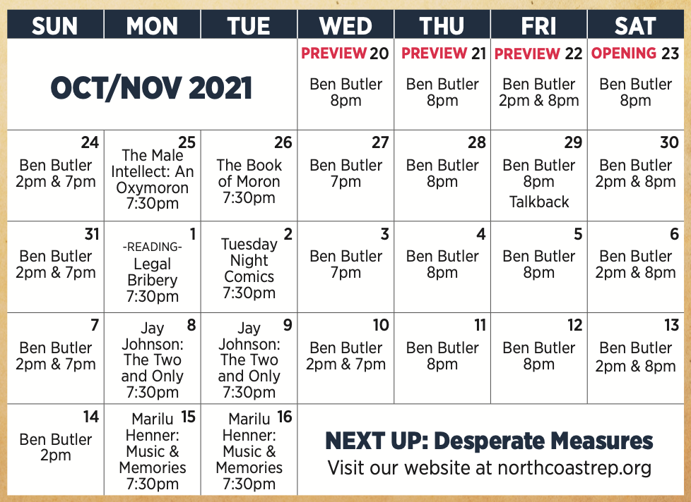

FACT SHEET:

WHAT: NORTH COAST REPERTORY THEATRE presents
BEN BUTLER
By Richard Strand
Directed by David Ellenstein

CAST: Richard Baird,* Brian Mackey,* Brandon J. Pierce,* Bruce Turk.*

WHERE: North Coast Repertory Theatre
987 Lomas Santa Fe Drive
Solana Beach, CA 92075

SCHEDULE: Previews: October 20, 2021
Closes: November 14, 2021
Wed. @ 7pm, Thurs-Sat @ 8PM; Sat & Sun @ 2PM, Sun @ 7pm
Preview Matinee @ 2pm, Friday, October 22, 2021
Wednesday Matinee @ 2pm, November 10, 2021
Talkback with cast & director: Friday, October 29, 2021

PRICES: Previews (including Fri Mat) $54.00
Sat. Evening & Sunday Matinee $65.00
Wed. – Fri. Evening $60.00
Wed. & Sat. Matinee $60.00
Sunday Evening $57.00

DISCOUNTS: Seniors, Students, Military & Educators $3.00 off admission.

BIOS

RICHARD STRAND (Playwright) Richard Strand has had premieres at Victory Gardens Theater, GeVa Theatre, Steppenwolf Theatre, The Cricket Theatre, New Jersey Repertory Company, Detroit Repertory Theatre and a number of other venues. Two of his plays, The Bug and The Death of Zukasky, premiered at The Humana Festival at Actors Theatre of Louisville. Ten Percent of Molly Snyder, My Simple City and The Second-Story Man were written in Iowa City, Iowa where Mr. Strand was a member of the University of Iowa Playwright's Workshop. Ben Butler premiered at New Jersey Repertory Company and later moved to 59E59 in New York. Mr. Strand currently lives in California with his wife, Mary Lynn. He recently retired as the chairman of the theater department at Mt. San Antonio College in Walnut, California where he designed scenery and taught History of Theater and Playwriting.

DAVID ELLENSTEIN (Director) Born into a theatrical family, David has worked in theatres across the country. Before joining North Coast Rep in 2003 he served as Artistic Director for the Los Angeles Repertory Company and the Arizona Jewish Theatre Company (AJTC). A veteran of over 250 theatrical productions, directorial favorites include: North Coast Rep (Streaming) Dr. Glas, Becoming Dr. Ruth, Einstein Comes Through, Trying, A Christmas Carol, An Iliad, and Same Time, Next Year – (LIVE) The Outsider, All in the Timing, Holmes & Watson, A Funny Thing Happened on the Way to the Forum, The Father, This Random World, Travels with My Aunt, The Illusion, Hedda Gabler (World Premiere Translation), Way Downriver; William Faulkner’s ‘Old Man’ (West Coast Premiere), Sherlock Holmes and the Adventure of the Great Nome Gold Rush (World Premiere), Side By Side By Sondheim, Chapter Two, Freud’s Last Session (San Diego Premiere), Faded Glory (World Premiere), Mandate Memories (World Premiere), Becoming Cuba (World Premiere), Time Stands Still, Words by: Ira Gershwin and the Great American Songbook (World Premiere), Two by Pinter: The Lover and The Dumb Waiter, HENRY IV Part 1, Heroes, My Name is Asher Lev, The Drawer Boy, Becky’s New Car, Ghosts, The Tempest, Talley’s Folly, Over the Tavern, Old Wicked Songs, The Dresser, Jacques Brel is Alive and Well and Living in Paris, Madagascar, A Shayna Maidel, The Honky-Tonk Angels, Rashomon, A Moon for the Misbegotten; Tuesdays With Morrie; Collected Stories; Halpern and Johnson; Romeo and Juliet; Amy’s View; Einstein Comes Through (also co-author); The Chosen; A Life in the Theatre; Story Theatre and Charley’s Aunt. Coconut Grove Playhouse - Sonia Flew starring Lucie Arnaz; Halpern and Johnson starring Hal Linden and Brian Murray. Papermill Playhouse - The Chosen starring Theodore Bikel and John Lloyd Young. 59E59 - His Royal Hipness Lord Buckley. Park Square & Colony Theatre – Words By. Portland Stage - Halpern and Johnson. Renaissance Theatre - Long Day’s Journey Into Night. Actor’s Theatre of Phoenix - Rabbit Hole. Alabama Shakespeare Festival - The Glass Menagerie, Rocket City (World Premiere) and Honky-Tonk Angels. Laguna Playhouse - Chapatti, Alexandros (World Premiere). Southwest Shakespeare Company - Cyrano de Bergerac. AJTC - Awake and Sing. Meadow Brook Theatre - A Christmas Carol. Portland Rep - Conversations with My Father and Gaslamp Quarter Theatre - A Shayna Maidel. Winner of numerous theatre awards, including the San Diego Theatre Critics Circle Award for “2018 Director of the Year.”

RICHARD BAIRD* (Major General Benjamin Butler) is an award-winning actor, director and producer. Richard is the Founding Artistic Director of New Fortune Theatre Company where he has directed and appeared in Henry the Fifth (Craig Noel San Diego Critics Circle awards for Outstanding Direction and Lead Performance), The Birthday Party (McCann) and Les Liaisons Dangereuses (co-director/Valmont). He is always excited to return to NCRT where he has been acting and directing since 1999. Richard has appeared in regional theatres across the country, including The Old Globe, Santa Barbara Theatre Ensemble, Backyard Renaissance, San Diego Rep, Oregon Shakespeare Festival, Chicago Shakespeare Theatre, Portland Centre Stage, Shakespeare Santa Cruz, Arizona Theatre Company, Southwest Shakespeare Company (AriZoni Best Actor for Cyrano and Petruchio in Taming of the Shrew), Kingsmen Shakespeare and has directed for Backyard Renaissance, Southwest Shakespeare, Intrepid Theatre and Diversionary Theatre. He has appeared in fifty productions of Shakespeare’s plays.

BRIAN MACKEY* (Lieutenant Kelly) is thrilled to be back at North Coast Rep, where he was last seen in A Christmas Carol and Little Women. Other San Diego credits include Noises Off, Alice, Ring Round the Moon, The Explorer’s Club, Silent Sky, Jewel in the Crown City, Smoke on the Mountain, Equivocation, Dinner with Marlene, The Angel’s Arms, The Nerd, An American Christmas, Twelfth Night (Lamb’s Players): The Importance of Being Earnest, Travesties, The Glass Menagerie, History Boys, Christmas Carol (Cygnet); The Pride, The Little Dog Laughed, Baby with the Bathwater, As Much As You Can, Corpus Christi (Diversionary); In the Next Room or The Vibrator Play, The Humans (San Diego REP); Smokefall, Abundance (Backyard Renaissance); All My Sons, Hamlet, A Midsummer Night’s Dream: The Musical, An Enemy of the People (Intrepid Theatre); Romeo, Romeo and Juliet (Roustabouts Theatre); In the Heat of the Night, The Woolgatherer, Bash: Latter-Day Plays, Jack Goes Boating, All in the Timing, A Streetcar Named Desire, The Grapes of Wrath (ion theatre); Born Yesterday (AVO Playhouse); Night Sky (Mo’olelo); The Heidi Chronicles, Julius Caesar (New Village Arts); Side Man (BANG!). Brian can next be seen in A Christmas Carol at Lamb’s Players Theatre.

BRANDON J. PIERCE* (Shepard Mallory) is thrilled to be making his North Coast Rep debut! Based in New York and Philadelphia, his credits include: Off-Broadway: Exit Strategy (Primary Stages) Regional: Native Son (Playmakers Rep.) Skeleton Crew (Portland Stage); Sweat (People’s Light); Fat Ham, Kill Move Paradise (Wilma Theatre); Welcome to Fear City (KC Rep); Shakespeare in Love (PSF); A Midsummer Night's Dream, Metamorphoses (Arden Theatre Company). Love to Alexandra, Mom and Dad! Coming up: Birthday Candles with Roundabout Theatre.

BRUCE TURK* (Major Cary) North Coast Rep: Same Time, Next Year, Faded Glory, Freud’s Last Session, Hedda Gabler, At This Evening’s Performance, Now You See It (director); has performed On and Off-Broadway, internationally, and at major regional theatres across the country. He has been a resident member of Tadashi Suzuki’s Acting Company in Japan, a Resident Artist at Hartford Stage, and a recipient of the TCG/Fox Fellowship for Distinguished Achievement. San Diego audiences have seen his work in fifteen productions of Shakespeare at the Old Globe Theatre, where he received the San Diego Critics’ Craig Noel Award for Leontes in The Winter’s Tale. Other credits include seasons and productions at American Conservatory Theatre, Pasadena Playhouse, Seattle Repertory, McCarter Theatre, La Jolla Playhouse, The Denver Center, The Cincinnati Playhouse, The Goodman Theatre, The Shakespeare Theaters in DC, New Jersey and Santa Cruz, and many more. Screen credits include “Murder in the First,” “NUMB3RS,” “ER,” "L&O:SVU," and “Third Watch.” He is a graduate of Northwestern University.

DESIGN TEAM
AARON RUMLEY* ( Stage Manager) has worked on over 120 shows at North Coast Rep, over 50 as a stage manager, over 20 as a designer.
MARTY BURNETT (Set Design) Resident Designer at North Coast Rep since 1992 and has designed more than 200 productions for the theater. Other design venues include Sahara and Hacienda hotels in Las Vegas, Claridge Hotel, Atlantic City and Drury Lane Chicago.
RENETTA LLOYD (Costume Design) is thrilled to be back at North Coast Rep for this production. She has been working as a costumer in North County San Diego for over 15 years. Her work has been seen at Moonlight Amphitheatre, Mira Costa College and several other local theatre companies. When not working on a show, she enjoys designing custom creations for conventions and other costumed events. When not sewing, she is mostly found chauffeuring her two young kiddos around town! Keep up with all her creative projects on Instagram @Natty.Lou.Creations. Enjoy the show!
MATTHEW NOVOTNY (Light Design) is pleased to be designing another show for North Coast Rep, where he has designed close to forty shows over the past seven years. Matthew is currently the Lighting Designer in Residence for San Diego Musical Theatre as well as North Coast Rep, and his work can be seen at a wide variety of theatres across San Diego. Matthew holds a B.A. in Technical Theatre from San Diego State and a master’s degree in Lighting Design from Boston University. Matthew is married to his beautiful wife Amanda, with 5 AMAZING children: Ragan, Harper, Heston, Maddex and Harrison .
PHILLIP KORTH (COVID-19 Compliance Officer/Props) is an actor, writer, craftsman, and educator. He earned BA in Acting and Creative Writing from Western Michigan University and his MFA in Acting from the University of Connecticut. He is a Veteran of the United States Marine Corps and served two tours of duty in Iraq. In addition to designing and managing props for NCRT, Phillip is also the Education Associate at The Theatre School @ North Coast Rep.

About the North Coast Repertory Theatre:
North Coast Repertory Theatre, under the artistic leadership of David Ellenstein since 2003, is a professional Equity theatre founded in 1982 by Olive and Tom Blakistone. Currently celebrating its 40th season, North Coast Rep has received critical acclaim from media and audiences alike, and has evolved into one of the area’s leading performing arts organizations. North Coast Rep prides itself on employing the majority of its actors from Actors’ Equity Association for its high quality, award-winning productions, and staging works by established and emerging playwrights. Throughout its history, North Coast Rep has created a platform where artist and audience thrive through the intimacy of live theatre, recognizing the power of theatre to challenge complacency, revitalize the imagination, nurture the unexpected, and embrace the variety and diversity in our lives.
###

